Inanay

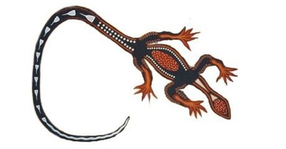
Inanay gupu wanna
Inanay gupu wanna
Ay ay ay oola
Oola oola oola ay
Yippee yay yipee yay
Goo wana goo wana
Goo wana goo wana
Goo wah - Choo!
Hints and Tips:
- This is a song in Yorta Yorta, the language of one of the Torres Strait Islander tribes of Victoria.
- It cannot be translated word for word, however, research shows it a song about a goanna, the 'choo' is shooing the goanna away. The word 'goanna' is the English name for the animal, it was their closest approximation of the name Aboriginals used for the animal.

https://aussiechildcarenetwork.com.au/activities/rhymes-and-songs/inanay

